HO CHI MINH CITY UNIVERSITY OF TECHNOLOGY
INSTITUTE OF INTERNATIONAL EDUCATION
Course: Advanced Database Systems

WEEK 01 REPORT

Development Environment & User Interface (UI)
Project title: Student Management System
Group members:
- Trần Duy Thành
- Nguyễn Đình Quốc
- Lê Nguyễn Bảo Khang
- Nguyễn Đình Phước
Week: 01
Topic: Development Environment & UI

1. Introduction
This project aims to develop a Student Management System as part of the Advanced Database Systems course. The system is designed to support basic academic management activities such as managing student information, data input/output, and later integration with database systems.
In Week 01, the group focuses on: - Setting up the Java application development environment. - Selecting appropriate technologies and frameworks. - Building a basic User Interface (UI) to demonstrate core UI components.
The objective of this week is not database integration, but to establish a stable development environment and demonstrate a functional UI prototype for the system

2. Development Environment

2.1 Technology Stack
The following technologies and tools are used in the project:
- Programming Language: Java (JDK)
- Framework: Spring Boot
- UI Framework: Vaadin Flow (server-side Java UI framework)
- IDE: Visual Studio Code / IntelliJ IDEA
- Build Tool: Maven
These technologies were selected to ensure: - Strong integration with Java backend systems - Rapid UI development - High maintainability and scalability - Compatibility with future database integration

2.2 Environment Setup Overview
The development environment includes: - Java Development Kit (JDK) - Java IDE (VS Code / IntelliJ IDEA) - Spring Boot project structure - Maven dependency management - Vaadin Flow integration for UI development
The project follows a layered structure including: - entity – controller - service - repository - ui – user interface layer - config
  - 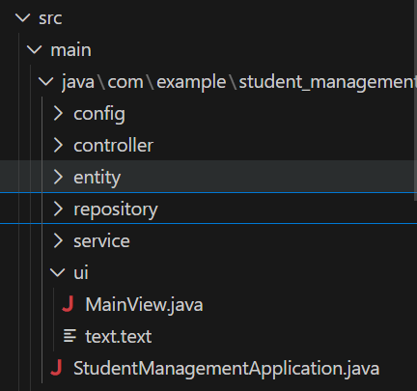
  - Figure 1. Project structure of the Student Management System following layered architecture.
This structure ensures scalability and clear separation of responsibilities between system components

3. User Interface Design for Student Management System

3.1 UI Purpose
The User Interface is designed to simulate a basic Student Management System. It allows users to input, view, and manage student information through an intuitive web interface.
At this stage (Week 01), data is processed using in-memory storage, without database connectivity, in accordance with course requirements.

3.2 Implemented UI Components
The UI demonstrates the following basic components as required:
- TextField
  - Student name
  - Email address
  - Phone number
- DatePicker
  - Date of birth
- ComboBox
  - Gender selection
- Button
  - Add student
  - Delete selected student
- Grid (Table)
  - Display student list
These components demonstrate core UI interaction patterns for a web-based Java application.

3.3 Data Handling
All data operations in Week 01 are handled using in-memory lists. No database connection is implemented at this stage.
This design strictly follows the Week 01 requirement: > Database connection is not required for this week.

4. Demo Result
The implemented UI allows users to: - Input student information - Display student data in a table - Perform basic add and delete operations
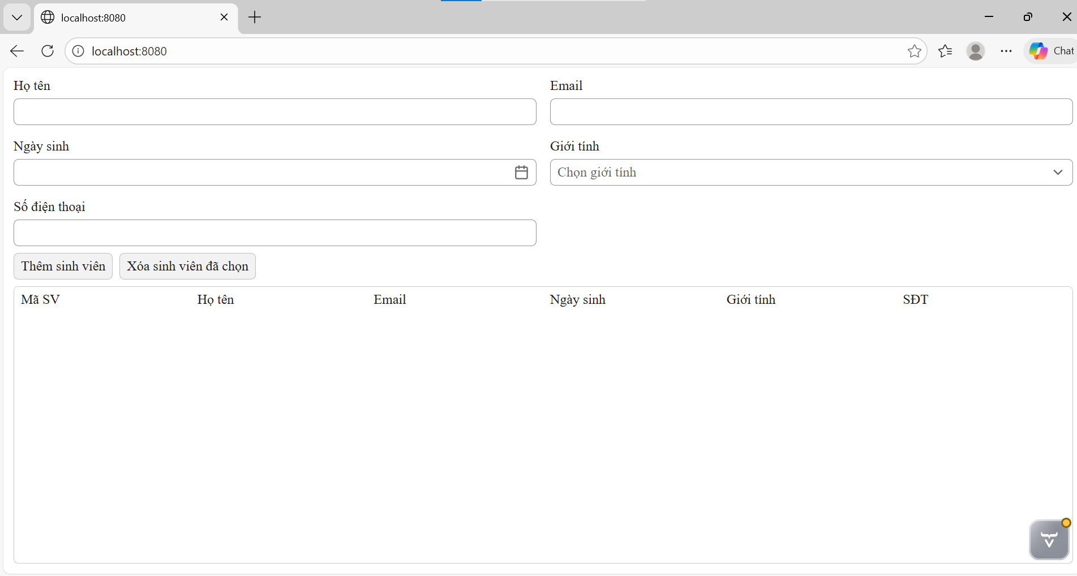
Figure 2. Initial User Interface of the Student Management System.
The interface successfully demonstrates: - Form-based input - Component interaction - Data visualization using grid/table
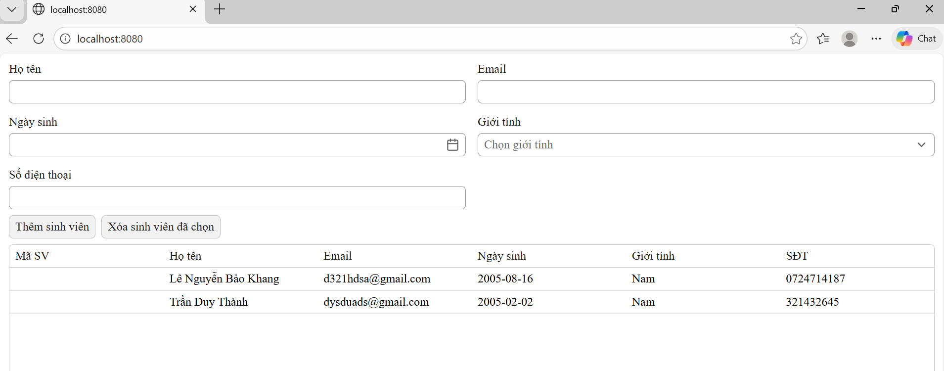
Figure 3. Student data displayed in Grid component after user input.

5. Conclusion and Next Plan
In Week 01, the group has successfully: - Set up the Java development environment - Built a structured Spring Boot project - Designed and implemented a basic UI for the Student Management System - Demonstrated required UI components according to course requirements

Next Steps (Week 02):
In the next phase, the group will focus on: - Database integration - Implementing CRUD operations - Data persistence - JDBC/ORM connectivity - Transfer of data between UI and database
This will enable the system to evolve from a UI prototype into a fully functional data-driven application.

End of Week 01 Report

